Table of Contents

Introduction 2

Problem Definition 2

Project Requirements 3

Project Implementation 3

IoT Device 3

Hardware 3

Software 3

M2M 4

Internet Connectivity 4

Data Visualisation 4

Additional 4

System Design 5

IoT Device Components 5

Network Infrastructure 5

Cloud Services 5

PCs 5

Circuit Design 6

Project Testing phase 6

Data Analytics 6

Legal & Ethical Evaluation 6

Legal Considerations 6

Ethical Considerations 6

Commercial & Economic Context 6

Sustainability & Equality, Diversity, and Inclusion (EDI) Issues 6

Conclusion 7

Source code 7

Reference 7

Appendix 8

# Introduction

This project delves into the realm of IoT, focusing on the development of a smart environmental monitoring system. With a core objective of addressing the critical need for real-time temperature monitoring in living spaces, this project integrates cutting-edge hardware, software, and connectivity technologies to create a responsive and user-centric solution.

## Problem Definition

The demographic landscape is undergoing a transformative shift globally, with an increasing aging population requiring specialised attention and care. One prominent challenge faced by the elderly and their caregivers is the need for real-time monitoring of environmental conditions, particularly temperature variations, within living spaces. [insert reference] In many instances, maintaining a comfortable and safe environment becomes a critical factor in ensuring the health and well-being of elderly individuals, especially when their ability to regulate their surroundings may be compromised. [insert reference]

Research shows that traditional monitoring systems often fall short in providing a seamless, unobtrusive solution tailored to the unique needs of the elderly. [insert reference] Therefore, this project aims to develop an innovative IoT-based solution utilising temperature sensors and data analytics to create a responsive environment. By doing so, the project aims to enhance the quality of life for elderly individuals while additionally supporting caregivers in their responsibilities. [insert reference]

This project will delve into the intricacies of hardware and software integration, exploring the capabilities of Arduino-based technology, and importance of cloud-based services for efficient data storage and analytics. It is anticipated that this project will not only address a specific problem but also contribute to the broader discourse on the responsible and inclusive use of technology in the realm of elderly care.

# Project Requirements

The following breaks down the project requirements.

1. IoT Device
   1. Temperature Sensor
   2. Backlight Display
   3. IoT Software
2. Utilise some aspect of machine two machine (M2M) connectivity.
3. Use internet connectivity.
4. Use data storage and data analytics using any IoT platform.

# Project Implementation

The project implementations require a range of hardware, software, and cloud services to achieve the objectives outlined in the introduction and project requirements (see Figure 1). Below explains how the Arduino program intelligently manages temperature data, adjusting LCD display colours, synchronising time through network time protocol (NTP), establishing machine to machine (M2M) connectivity via messaging protocol (MQTT), and visualising data on ThingSpeak through hypertext transfer protocol (HTTP) communication.

## IoT Device

### Hardware

* **Arduino Uno Wi-Fi R2 Board:** This board will provide seamless integration of IoT sensors, providing the necessary computational power for data processing and transmission.
* **Grove Seeed Studio Temperature Sensor v1.3:** This is a precise temperature sensor compatible with the Arduino board that will ensure accurate and real-time environmental monitoring within living spaces.
* **Grove-LCD RGB Backlight Display v5.0:** This will provide a clear visual representation of temperature variations. The visual feedback enhances user comprehension and interaction.
* **Power Supply:** In development mode, the Arduino is powered through USB connected to a PC. During runtime, a reliable 9V battery ensures continuous operation and sustained data capture, optimising energy efficiency for prolonged usage.

### Software

* **VS Code IDE:** Visual Studio Code (VS Code) Integrated Development Environment (IDE) has been chosen for programming the Arduino board. This platform streamlines firmware development and code editing, providing a user-friendly interface for efficient project development.
* **Programming Languages**: Arduino Sketch (C++) is the programming language used for the project. This language facilitates seamless communication between the Arduino board and the connected sensors, enabling effective data processing and transmission.
* **Code Design**: Temperature thresholds are defined to determine the colour of the Arduino LCD display. Green signifies an optimal temperature, blue indicates cold temperatures, and red warns of high temperatures. The Arduino program dynamically adjusts the LCD display colour based on predefined temperature thresholds.

The code design will include configurations to establish internet connectivity using Domain Name System (DNS), ensuring accurate time updates through Network Time Protocol (NTP) while also obtaining network settings seamlessly through Dynamic Host Configuration Protocol (DHCP). The Arduino program will enable M2M communication with cloud services via MQTT with Mosquitto and SMS with Twilio. Additionally, data updates will be sent to ThingSpeak for data visualisation and data analytics. These configurations are vital for the project's functionality.

## M2M

* **MQTT Mosquitto Platform:** MQTT via Mosquitto has been chosen to establish machine-to-machine (M2M) connectivity, with the Arduino serving as the MQTT publisher. The MQTT broker at test.mosquitto.org facilitates communication, ensuring reliable data transmission between the Arduino and other connected devices e.g. PC (see Figure 2).

The PC establishes a connection to the MQTT broker by subscribing via the command prompt. By opening the Mosquitto folder “C:\Program Files\mosquitto”, the following command, “mosquitto_sub -h test.mosquitto.org -t warmth-checker”, establishes a connection to enable periodic temperature updates alongside the time at which the temperature sample was taken.

* **SMS Twilio Platform:** The Twilio platform has been chosen to establish a M2M connection, enhancing communication through SMS messages sent to a designated mobile phone. To achieve this, an SMS provider receives real-time updates from the MQTT broker through a Python monitoring module that subscribes to the MQTT broker (see Figure 3). Notably, the project utilises the Patho python library to enhance the efficiency and reliability of SMS communication within the system. This integration ensures timely notifications, enhancing the project's overall communication capabilities.

## Internet Connectivity

* **Router**: A reliable internet connection is necessary for efficient data transmission between the Arduino device, ThingSpeak, and the MQTT broker. A stable connection is paramount for the project's real-time responsiveness.
* **Network Time Protocol (NTP):** NTP is utilised to maintain real-time accuracy on the Arduino. This ensures synchronised and precise timestamps for temperature updates, contributing to the overall effectiveness of the project.
* **Domain Name Server (DNS):** DNS serves as a name resolution service, converting human-readable domain names into IP addresses. In the context of the project, DNS enables the Arduino to connect to cloud services and other network entities using readable network addresses.
* **Dynamic Host Configuration Protocol (DHCP):** DHCP is employed to dynamically assign IP addresses to the Arduino device. This automated process simplifies network configuration, allowing the Arduino to operate seamlessly on a Wi-Fi network without manual IP address assignments.

## Data Visualisation

* **ThingSpeak Platform:** ThingSpeak is selected as the project's cloud platform for database management, data visualisation, analytics, and storage. Its user-friendly interface simplifies these processes. A dedicated channel in ThingSpeak is set up to receive and analyse data sent from the Arduino. The platform acts as the central hub for data storage and analytics, providing real-time insights through its intuitive user interface (see Figure 4).

ThingSpeak organises data into channels, acting as containers for specific IoT devices. Each channel comprises fields representing different data types. Three fields were used which were, temperature time (the time at which the temperature sample was taken against the time it was received on ThingSpeak), temperature (the temperature at a given time), and temperature state (0 for ok, 1 for hot, and 2 for cold). The Arduino program utilises ThingSpeak APIs and structures data to align with ThingSpeak's channel and field architecture. This ensures seamless and efficient organisation and retrieval of temperature-related information.

## Additional

* **Responsive Environment:** The project incorporates a responsive environment that dynamically adjusts to temperature variations. This adaptability activates the LED display to communicate changes, enhancing user interaction and the project's overall environmental responsiveness.

# System Design

The architecture of the IoT-based temperature monitoring system revolves around the seamless operation of the Arduino program, orchestrating real-time temperature monitoring and visuali***s***ation through a variety of communication channels. The system design is detailed below, outlining key components and their interactions (see Figure 5).

## IoT Device Components

1. **MQTT Publisher**: The Arduino is configured as an MQTT publisher, responsible for sending temperature and time updates to the MQTT broker.
2. **HTTP Client**: The Arduino serves as an HTTP client, leveraging the HTTP service supported by ThingSpeak for the seamless transfer of temperature data to designated channels.
3. **NTP Client**: Utilising the Network Time Protocol (NTP), the Arduino synchronises its internal clock with an NTP server, ensuring accurate and real-time timekeeping, displayed alongside temperature updates when monitored through MQTT.

## Network Infrastructure

1. **Router**: Ensures a stable internet connection via Wi-Fi is maintained for efficient data transmission.
2. **DNS**: Provides domain name resolution services, converting human-readable domain names into IP addresses for connection to cloud services and other network entities.
3. **DHCP**: Dynamically assigns IP addresses to the Arduino, simplifying network configuration and enabling seamless operation on a Wi-Fi network without manual IP assignments.

## Cloud Services

1. **MQTT Broker**: Facilitated by Mosquitto, the MQTT broker establishes machine-to-machine (M2M) connectivity. The Arduino, configured as an MQTT publisher, sends temperature and time updates to the broker, allowing other devices such as PCs to subscribe and receive real-time information.
2. **HTTP Service**: HTTP, supported by ThingSpeak, is used for communication between the Arduino and the cloud platform. It facilitates the seamless transfer of temperature data to ThingSpeak channels. The Arduino program incorporates HTTP protocols to send and receive temperature data, leveraging ThingSpeak's APIs for robust interaction.
3. **NTP Service**: Network Time Protocol (NTP) is utilised to acquire the current time, which is then displayed alongside the temperature when monitoring the device via MQTT. The Arduino program synchronises its internal clock with an NTP server, ensuring accurate and real-time timekeeping alongside temperature updates.
4. **SMS Provider**: The system integrates with an SMS provider, acquiring data from the MQTT broker via a Python monitoring module. This data is used to send SMS notifications to designated contacts, providing crucial alerts through mobile phone providers.

## PCs

1. **Data Visualisation**: PCs act as recipients of temperature data, transforming raw information into a user-friendly visual format, providing a clear representation of temperature variations.
2. **MQTT Subscriber**: The PC establishes a connection to the MQTT broker by subscribing. Through this subscription, the PC receives temperature updates in real-time, ensuring an up-to-date representation of environmental conditions.
3. **Carer Monitor**: The Carer Monitor, a Python module, actively retrieves data from the MQTT broker and forwards it to the SMS provider for notifying designated contacts. This ensures timely communication and enhances the overall responsiveness of the system.

# Circuit Design

Insert circuit design

# Project Testing phase

The testing phase is a crucial step to ensure the reliability and functionality of the IoT artifact. The following provides details of the tests required to be conducted to validate various aspects of the system.

To test all aspects of the artifact VS Code must be open and the Arduino must be connected to a PC through a USB connection. The serial monitor must be opened and have the correct settings must be set in place (see Figure 11). Selecting ‘start monitoring’ will begin to display all the processes that Arduino is doing with periodic updates being sent to the terminal. On successful connection the following tests can then be performed.

* **Hardware Integration Testing**: To check the compatibility and seamless integration of Arduino components, and ensure the temperature sensor, LCD display, and connectivity modules are working together harmoniously, a check to ensure the firmware can be programmed on to the Arduino is necessary (see Figure 12). When hardware is successfully connected, the serial monitor will display periodic real-time updates of the Arduino temperature samples (see Figure 15).  
  1. **LCD Display**: When the Arduino has established power via the USB or battery, the LCD should light up and display a blue colour indicating a successful connection to power. As the temperature variates and crosses the temperature thresholds that have been programmed, the screen will remain green for ok, red for too hot and blue for too cold. Heating up the sensor via a hair dryer should change the LCD display to red for too hot. Additionally, by using ice cubes in a bowl and placing it next to the sensor will cool down the temperature and change the display to blue for too cold. (see Figure 14).
  2. **Temperature Sensing Accuracy**: The precision of the temperature sensor needs to be verified by comparing its readings with known temperatures in a controlled environment. Using a thermometer, on success, the temperature sensor must provide the same reading +/- 4 degrees Celsius. The temperature detected by the sensor will be displayed inside the terminal of the serial monitor as well as the LCD display (see Figure 15).
* **Network Connectivity**: To test the device's ability to connect to the internet and ensure stable and reliable communication with cloud services such as the MQTT broker, error handling has been incorporating in the Arduino artifact. The LCD display will display text if no Wi-Fi connection can be found. Additionally, by opening the serial monitor the terminal should display weather a successful Wi-Fi connection has been established or not. By turning off the router the serial monitor will show that the device is not connected to the internet. Additionally, by turning on the router the serial monitor will show that the device has established an internet connection via the desired router (see Figure 16, 17).
* **Machine-to-Machine Connectivity (M2M)**: To confirm the successful establishment of M2M communication to validate that the Arduino can publish real-time temperature updates via MQTT, and other devices can subscribe to these updates. A test can be performed by opening a command prompt and entering the following the command in the Mosquitto program; “mosquitto_sub -h test.mosquitto.org -t warmth-checker”. On successful subscription, periodic updates will be displayed of the current temperature detected by the device alongside timestamps (see Figure 18). Additionally, the serial monitor in VS Code will display successful connection to the MQTT broker and NTP server (see Figure 17) as well as when the Arduino publishes to the MQTT broker and gets updates from the NTP server (see Figure 21).
* **Data Storage and Analytics**: A check will need to be performed to ensure the proper functioning of ThingSpeak, ensuring the correct storage and visualisation of temperature data in the designated channels. By monitoring the Arduino via the serial monitor, on successful data transfer to ThingSpeak, a line will be printed to the terminal (see Figure 15). Then by going to the ThingSpeak website ‘https://thingspeak.com’ and viewing the correct channel for the artefact, graphs will be shown displaying the three fields temperature time, temperature, and temperature state (see Figure 6, 7, 8, 9, 10).
* **SMS Notification System**: A test can be performed to check the SMS notification system to ensure timely alerts are sent to designated contacts when critical temperature thresholds are reached. First, a terminal in VS Code should be open, then cd into the correct folder of the .py script, finally the following command can be entered to run the python script that will behave as the carer monitor ‘python warmth_monitor.py’. On success, periodic updates of the data being sent out to the MQTT broker from the Arduino will be displayed in the terminal. When the temperature state changes to either ‘too hot’ or ‘too cold’, the terminal will display a line indicting an SMS message is being sent. A text message to the dedicated mobile phone should follow (see Figure 18, 19).
* **User Interface Testing**: To evaluate the user interface and ensure that the LCD display effectively conveys temperature variations and the system's current status, a test can be performed to ensure a successful or unsuccessful Wi-Fi connection. By turning off the router the LCD display should display text reading ‘Not connected’. By turning on the router the LCD should display text reading the current temperature detected alongside the state. Changing the temperature of the environment should change the temperature and state (ok, hot, or cold) (see Figure 13).

# Legal & Ethical Evaluation

## Legal Considerations

* **Data Privacy**: Ensuring compliance with data privacy regulations will be necessary as the project involves collecting and transmitting data. This means adherence to laws like GDPR, or regional equivalents are important. The project implementation will need to include robust measures to protect user information. (encryption protocols and anonymise data)
* **Intellectual Property**: Consideration must be given to intellectual property rights; it is crucial to verify that the project does not infringe on existing patents or intellectual property rights. To ensure this all code and designs will adhere to open-source or appropriately licensed frameworks.

## Ethical Considerations

* **Informed Consent**: Users, especially the elderly and caregivers, should provide informed consent regarding data collection and usage. Clear documentation and consent forms for users will be necessary to provide transparent communication about the purpose of the system and the data it gathers fosters ethical practices.
* **Accessibility**: Ensuring the technology is accessible to individuals with diverse abilities promotes inclusivity. The project should consider factors like user interfaces suitable for those with impaired vision or hearing. To do this the project will utilise bright colour indicators of temperature as well as SMS notifications to users when there are significant temperature changes. Future alterations of the IoT device could include voice commands for users as well as a user-friendly interface for users to adjust of the temperature thresholds for the temperature sensor on the device as well as the Wi-Fi connection.

## Commercial & Economic Context

* **Cost-Effectiveness**: Ensuring that the technology remains affordable is paramount as it will help contribute to the device’s widespread use. Affordability will enhance accessibility particularly for those with limited financial resources. This device has been developed using affordable components from the Grove starter kit as well as a low-cost Arduino board. (Conduct a cost-benefit analysis considering both initial implementation costs and long-term maintenance expenses)

## Sustainability & Equality, Diversity, and Inclusion (EDI) Issues

* **Environmental Impact**: Evaluating the environmental impact of the project is crucial. Minimising energy consumption and utilising eco-friendly components contribute to the overall sustainability of the system. (Evaluate the environmental impact of the IoT device, considering its lifecycle.
* **Cultural Sensitivity**: Consideration of cultural differences is essential to ensure the project is respectful and inclusive. Adapting the system to diverse cultural norms and practices demonstrates a commitment to diversity.
* **Equitable Access**: Striving for equitable access ensures that the benefits of the project are not restricted to a specific demographic. Addressing socio-economic factors and providing solutions for various user groups contribute to a more inclusive system.
* **User Representation**: Ensuring diverse representation in the development process prevents biases and promotes a system that caters to a broader spectrum of users. Different perspectives contribute to the creation of a more inclusive and effective artifact.

# Conclusion

In summary, this project addresses the need for real-time monitoring. Using simple and smart technology, the system adapts to temperature changes, making life better for elderly individuals while also aiding caregivers. By combining easy-to-use hardware and software, this project not only solved a specific problem but also contributed to discussions on responsible technology use for elderly care.

Attention has been made to legal and ethical concerns, making sure the system respects privacy and intellectual property. It's a reliable, user-friendly solution that considers accessibility and fairness for everyone. The project successfully brings together different technologies, like SMS notifications and data visualisation and overall is a practical and impactful solution that improves the quality of life of an aging population, showing the positive side of innovative technology.

# Source code

Insert link to git hub

# Reference

# Appendix

## Project Architectural Diagrams

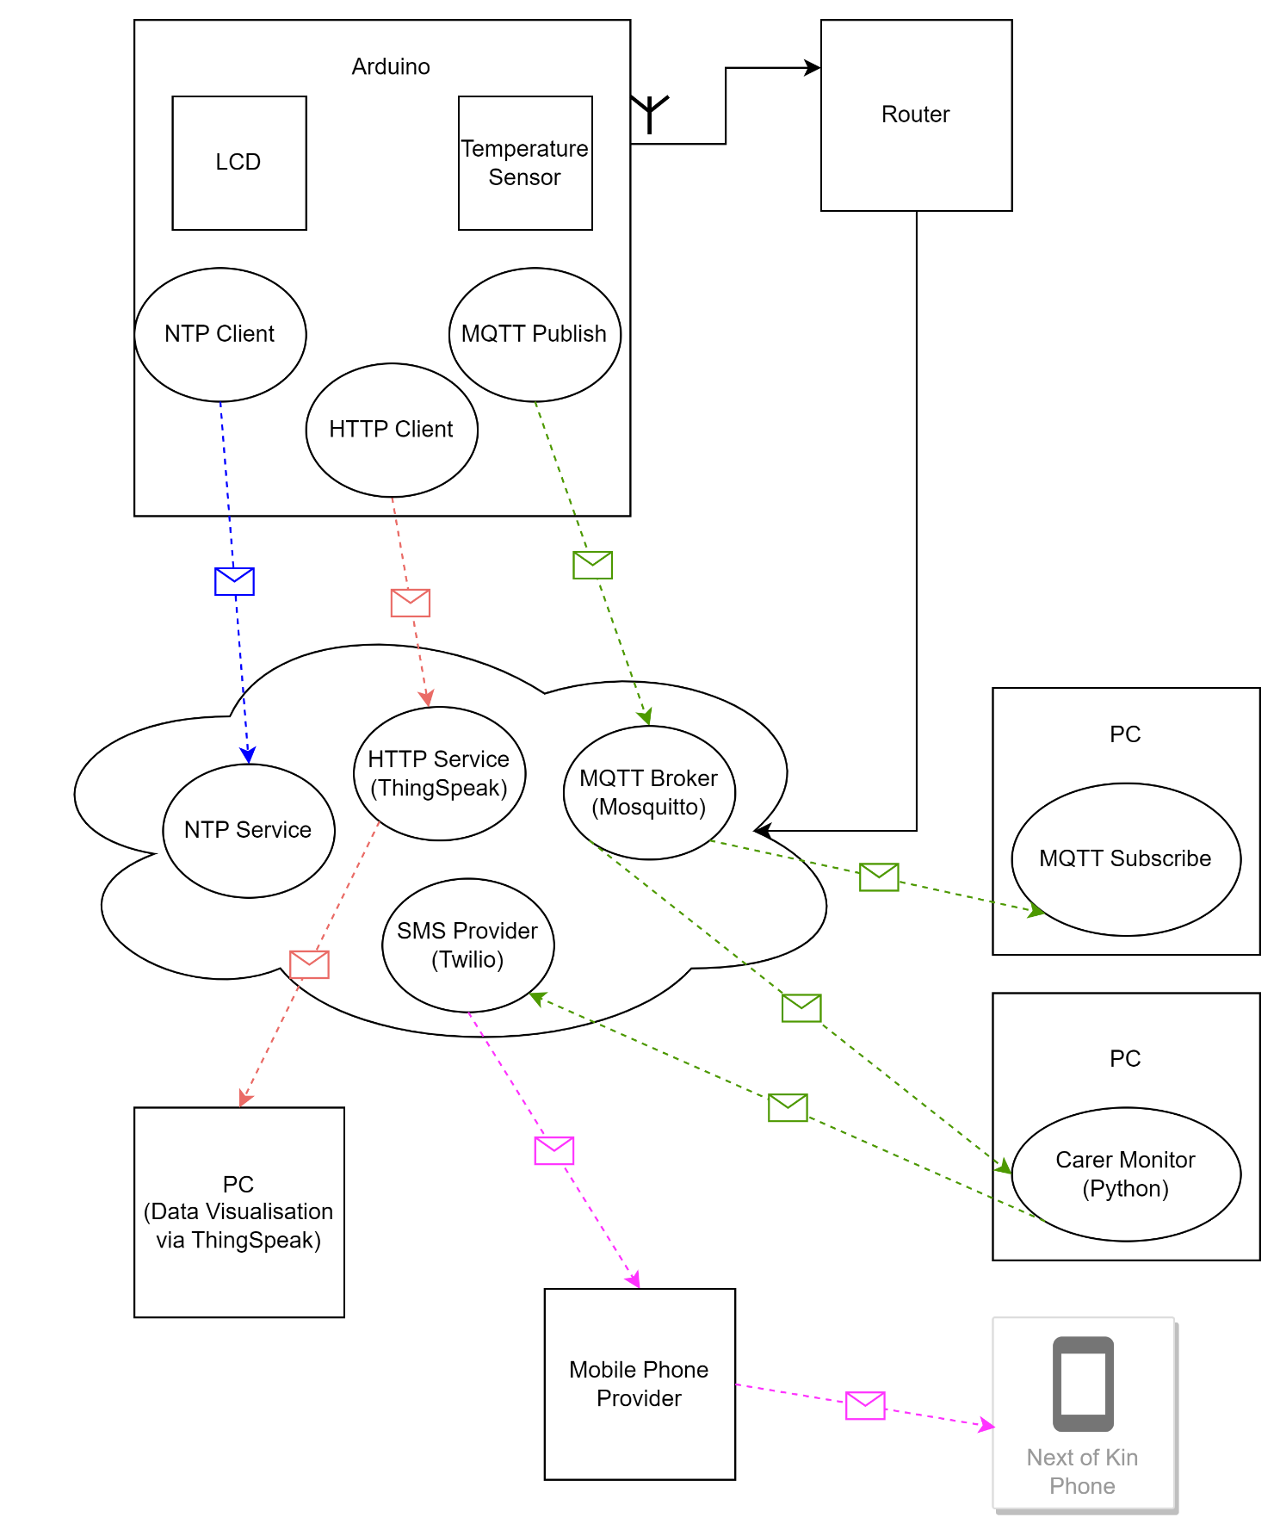

1. A project implementation diagram.

1. A project implementation diagram demonstrating M2M via an MQTT broker and subscriber.

1. A project implementation diagram demonstrating M2M via MQTT broker and subscriber including SMS notification .

1. A project implementation diagram demonstrating data visualisation.

1. A system design diagram.

## Circuit Design

1. The circuit diagram displaying the components used for the IoT artefact.

## Data Analytics

1. This displays the time at which a temperature sample was taken compared to the time at which the temperature sample was received by ThingSpeak.

1. This displays the temperature sample alongside the time at which the temperature sample was taken.

1. This displays the temperature sample alongside the time at which the temperature sample was taken.

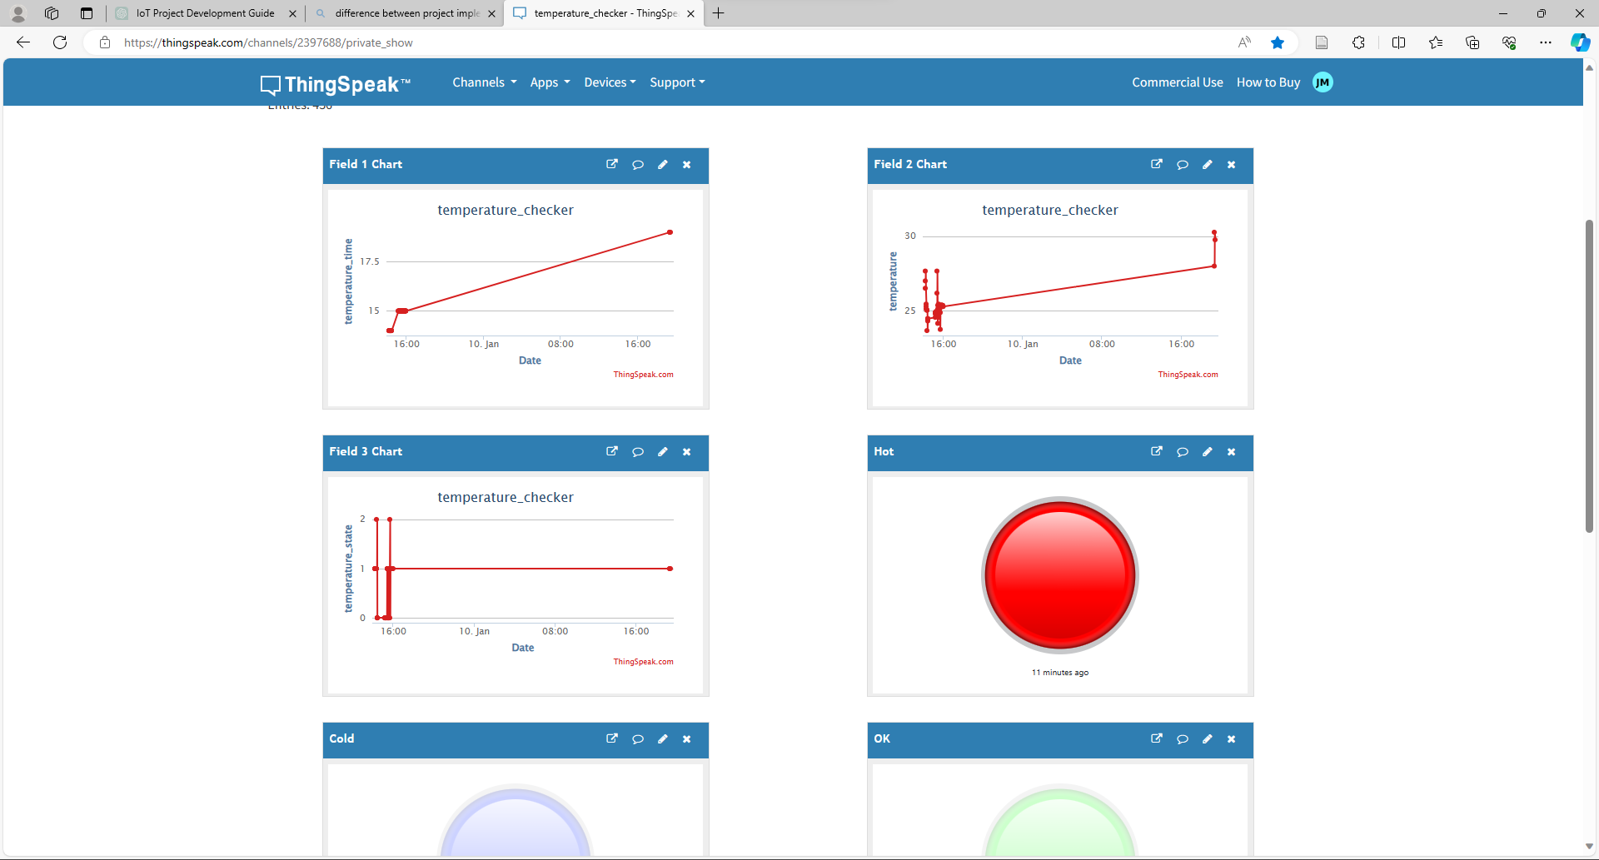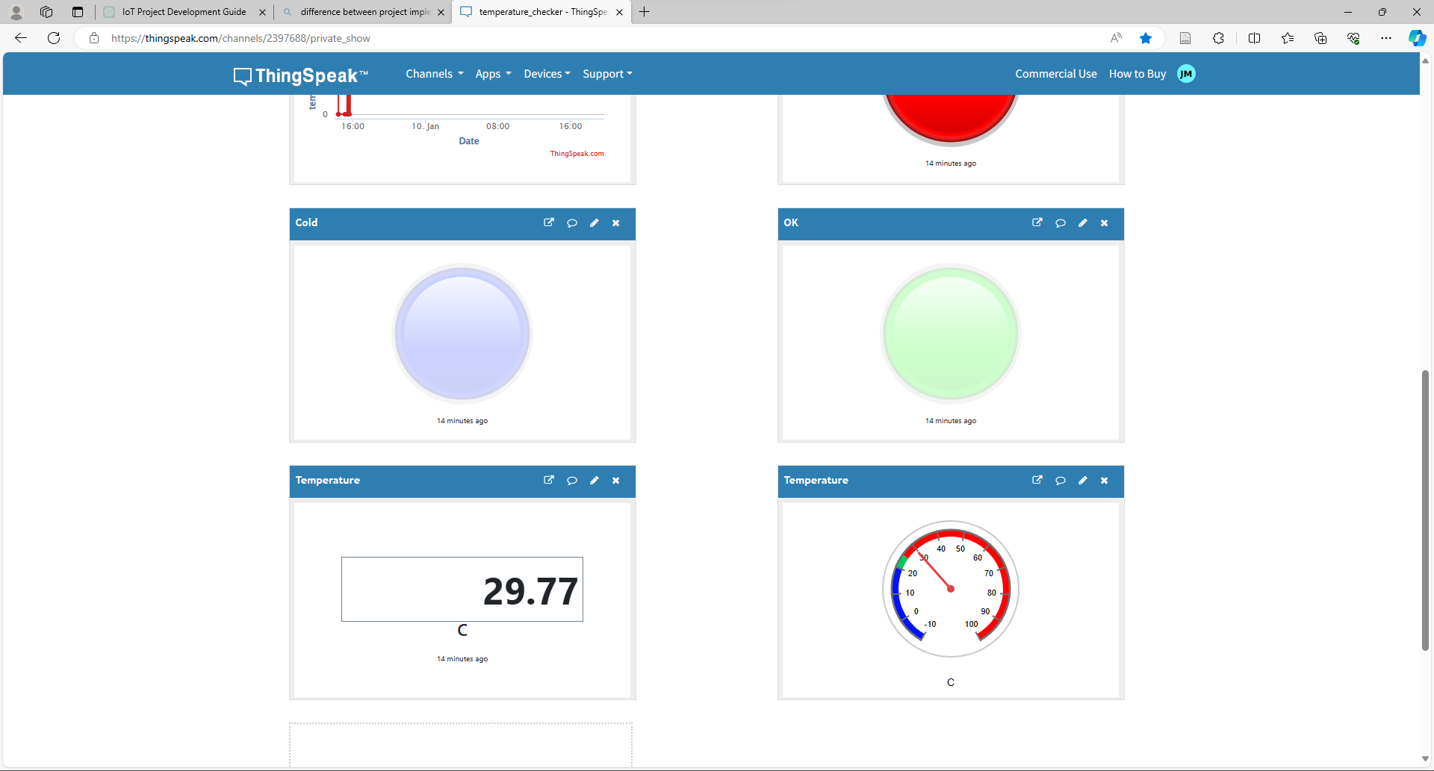

1. Figure 9. A quick visualisation of the state. Red for hot, blue for cold, green for ok.

1. A quick visualisation of the temperature sample as well as the temperature samples alongside their state. Red for hot, blue for cold, green for ok.

## Testing Phase

1. VS Code serial monitor settings.

1. VS Code output terminal displaying successful firmware upload to the Arduino.
2. LCD displaying blue for no internet connection, green for ok temperature state, red for hot and blue for cold.
3. The environment temperature detected by a thermometer (A). The temperature sensor sample can be seen via the VS Code serial monitor (B) and LCD Display (C).
4. VS Code serial monitor displaying unsuccessful connection to a Wi-Fi network, NTP server and MQTT broker.

1. VS Code serial monitor displaying successful connection to a Wi-Fi network, NTP server and MQTT broker.

1. Command Prompt displaying successful subscription to MQTT broker showing real time temperature samples.

1. VS Code terminal displaying successful python subscription to MQTT broker showing real time temperature samples. Additionally displaying successful messaging of ‘next of kin’.
2. Desired mobile phone being notified of temperature state change via SMS notification.
3. The Arduino temperature sample and successfully updating ThingSpeak as well as getting NTP server updates.